CS-340-T5534 Client/Server Development 23EW5

6-1 Milestone- Dashboard Data Visualizations

Jacob Simmons, 11 June 2023

* **Interactive Data Table**

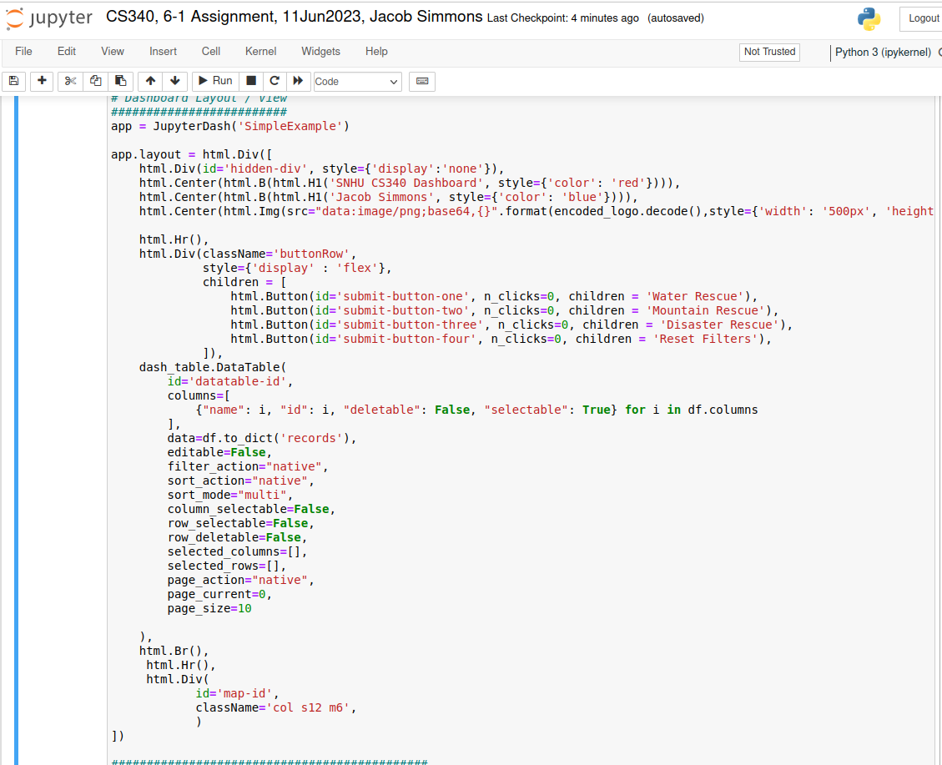

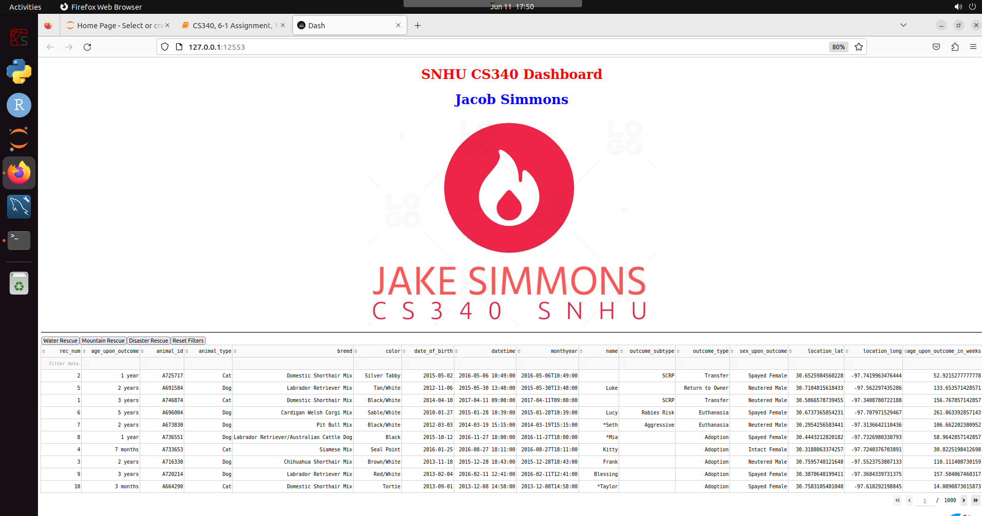

* **Geolocation Chart**

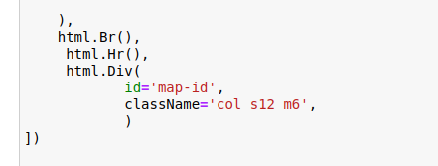

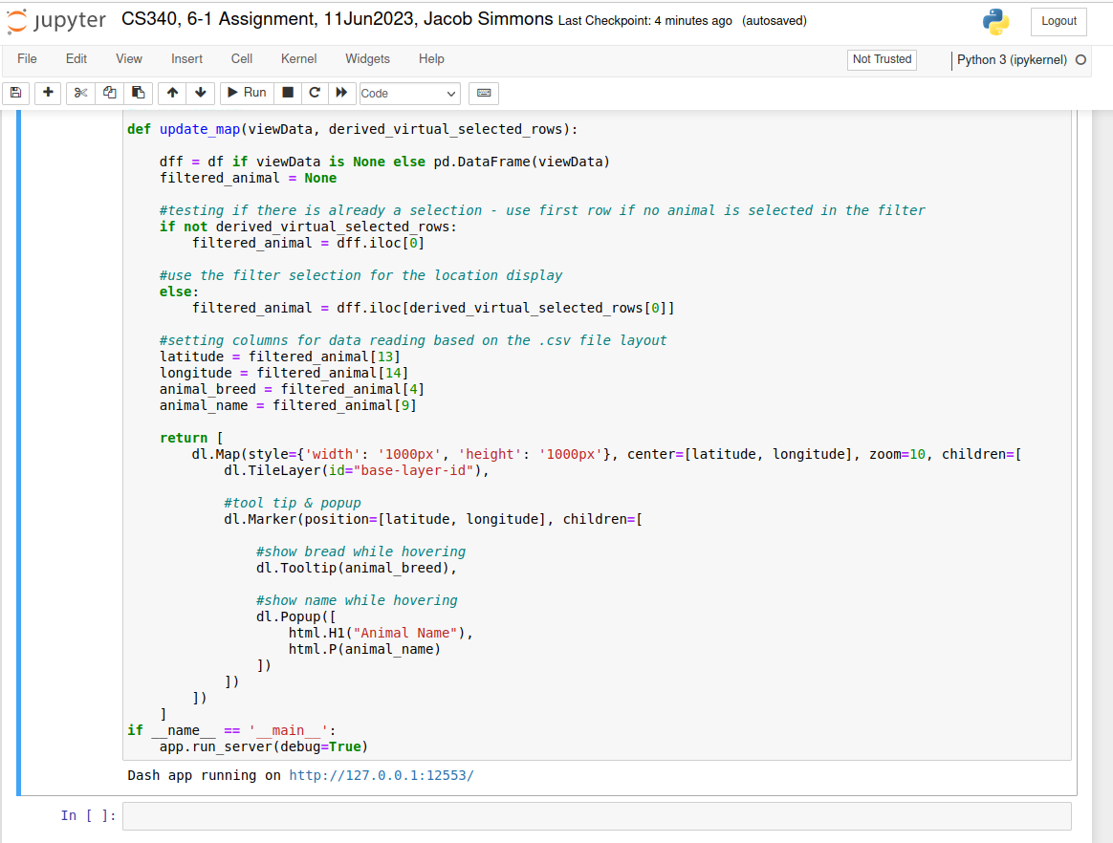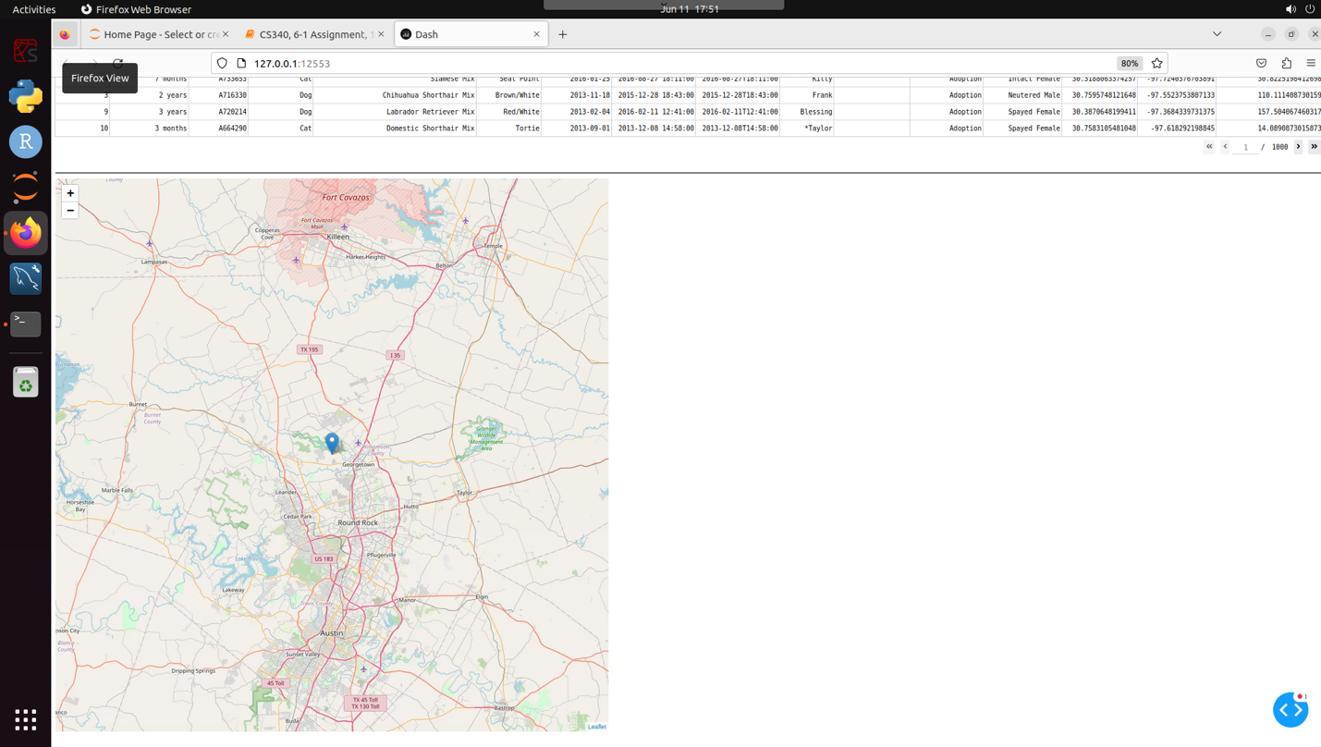

**References**

None